

AI DRIVEN FASHION RECOMMENDATIN SYSTEM BASED ON BODY SHAPE

D0CUMENT REPORT

**SUBMITTED BY:**

**AATIQA SADIQ ID: F2022332066**

**MAHWISH NASIR ID: F2022332060**

**SECTION: A2**

**SUBMITTED TO: MAM SHAISTA HABIB**

**Abstract**

This article introduces an advanced AI-driven personalized outfit recommendation system specifically designed to cater to individual body shapes. The proposed system integrates cutting-edge deep learning techniques and image analysis to offer tailored fashion suggestions, ensuring a more personalized and inclusive user experience.

The core of the system lies in leveraging convolutional neural networks (CNNs) and other deep learning architectures to analyze body shape, dimensions, and proportions. By training on diverse datasets containing labeled body types, the system learns to identify subtle variations in body structures and associate them with suitable clothing styles, colors, and patterns. This approach addresses key gaps in existing fashion recommendation systems, including the lack of personalization, limited understanding of body morphology, and the inability to adapt to diverse user needs.

The methodology encompasses multiple stages, beginning with extensive data collection from publicly available datasets and proprietary sources. This data undergoes preprocessing, including image augmentation and annotation, to enhance model training efficiency. The system incorporates advanced techniques like transfer learning, attention mechanisms, and multimodal analysis to refine outfit recommendations further. It also considers contextual factors such as occasion, season, and color preferences, ensuring a holistic recommendation process.

Results indicate significant improvements in recommendation accuracy and user satisfaction, showcasing the system’s ability to deliver precise and relevant outfit suggestions. The scalable architecture ensures adaptability to larger datasets and dynamic catalogs, making it feasible for real-world applications in fashion e-commerce platforms and personal styling tools.

This AI-driven approach has the potential to revolutionize how users interact with fashion technology, bridging the gap between algorithmic precision and human-centric personalization. By empowering users to make informed fashion choices that align with their unique body shapes, this system sets a new benchmark in the field of personalized fashion recommendation syste

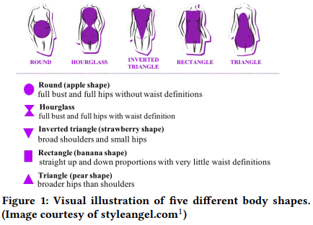

**Keywords**: Fashion Recommendation System, Deep learning, Body Shape dataset, Convolutional Neural, Networks CNN, Image classification.

**Introduction**

**“The dress must follow the body of a woman, not**

**the body following the shape of the dress.”**

**—** Hubert de Givenchy, fashion designer

**Context of Outfit Recommendation Systems**

Fashion plays a significant role in personal expression and confidence. However, choosing outfits that suit one’s body shape, size, and preferences remains a challenge for many. Current fashion recommendation systems often rely on generic algorithms that fail to consider the diversity of human body shapes and personalization needs.

**Gap in Existing Solutions**

While some recommendation systems incorporate style and occasion, they typically lack granularity in addressing the unique requirements of body shapes. Additionally, existing tools often overlook the combination of factors like size, occasion, and color preferences. This limitation reduces their effectiveness, especially for individuals seeking tailored advice. Bridging this gap is critical to creating a truly personalized experience.

**Objective**

This project aims to design an AI-driven system that recommends outfits based on body shape, size, and preferences. By combining image analysis, user input, and machine learning, the system ensures recommendations are both practical and visually appealing. The proposed solution integrates deep learning techniques to achieve this personalization.

**Data Diagram**

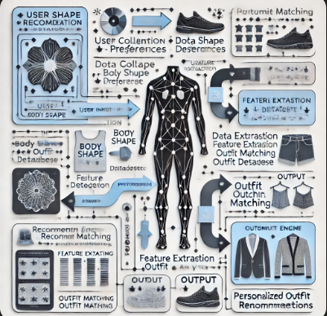

**Literature Review**

The following table compares existing research and systems in fashion recommendation:

|  |  |  |  |  |
| --- | --- | --- | --- | --- |
| **Title** | **Author** | **Methodology** | **Result** | **Gap** |
| What Dress Fits Me Best?: Fashion Recommendation on the Clothing Style for Personal Body Shape | Shintami Chusnul Hidayati, Cheng-Chun Hsu, Yu-Tingg, Kai-Lung Hua, Jianlong Fu, Wen-Huang Cheng | Developed a body shape-aware recommendation system using CNNs and clustering techniques to map correlations between body shapes and clothing styles. | **76.83%** | Limited exploration of user preferences and real-time deployment. |
| Advanced Fashion Recommendation System for Different Body Types using Deep Learning Models | Seema Wazarkar, Shruti Patil, Pratik S. Gupta, Kriti Singh, Mukund Khandelwal, C.V. Sri Vaishnavi, and Ketan Kotecha | The system uses pre-trained deep learning models like Xception, ResNet50, AlexNet, and VGG to classify clothing images and recommend outfits based on body types. | Highest Accuracy: Xception model achieved **94%** accuracy with a loss of **0.02%,** outperforming other models. | Limited dataset diversity focusing primarily on female fashion. |
| A Review of Modern Fashion Recommender Systems | Yashar Deldjoo, Fatemeh Nazary, Arnau Ramisa, **Julian McAuley**, Giovanni Pellegrini, Alejandro Bellogin, **Tommaso Di Noia** | Suggests items using collaborative filtering and computer vision, Utilizes neural networks, LSTMs, and attention mechanisms, Combines user body measurements and 3D models for tailored recommendations. | The paper highlights increased recommendation accuracy through the use of visual and multimodal features (e.g., CNNs, transformers) and systems like **BPR** and **VBPR** for personalized recommendations. | Limited user-item interactions and data for new fashion trends. Challenges in scaling RS for large, dynamic catalogs. |
| Clothes Style Recommendation System | W.H. Hsieh, B.F. Xue, J.C. Chen, Kawuu W. Lin, W.L. Chang | Uses **Active Shape Model (ASM)** to extract **14 geometric facial features**.  • Applies multi**-**label classification (Binary-Relevance & Label Powerset).  • Matches five facial shapes with seven clothing styles. | • Hamming loss: Label Powerset (0.0040) outperformed Binary-Relevance (0.1).  • F-score: Binary-Relevance was lower (0.0092). | • Ignores body shape and user preferences.  • Lighting conditions may affect accuracy.  • Limited fashion choices; predefined styles may not cover all preferences. |
| Smart Fashion Recommendation System using Random Forest Algorithm | Shivangi Patel, Shamneesh Sharma, Arneet Kaur, Vikas Verma, Theertha Sudheer Babu Nair, Nishant Agnihotri | The system uses **Random Forest** to recommend fashion based on **user preferences, body type, and occasion**. **Data preprocessing** ensures quality, and **feature extraction** selects key attributes. It achieved **84.6% accuracy**, outperforming other models. | • **Random Forest achieved 84.6% accuracy**, outperforming other models.  • **F1-score: 82.5%**, **Precision: 85.1%**, **Recall: 84.3%**. | • **Dependent on dataset quality**; may require updates for evolving fashion trends.  • **High computational cost** compared to simpler models |
| Advanced Fashion Recommendation System for Different Body Types using Deep Learning Models | S. S. S. R. Depuru et al. | Developed a deep learning model utilizing the Xception architecture to recommend clothing items based on different body shapes. Evaluated against multiple deep learning and traditional machine learning models. | Achieved 94% accuracy with a loss of 0.02%, outperforming other models in recommending suitable clothing items for various body types. | Limited dataset diversity; lacks real-time user feedback integration |
| Dress Style Recommendation Based on Female Body Shapes | Y. Zhang | |  | | --- | |  |  |  | | --- | |  |   Proposed a recommendation system that classifies female body shapes and suggests suitable dress styles accordingly. | Provided a framework for dress style recommendations tailored to different female body shapes. | Did not incorporate user preferences or contextual factors; limited to dress styles only. |
| Outfit Recommendation System Based On Body Shape | S. S. S. R. Depuru et al. | Developed a machine learning-based outfit suggestion system analyzing a dataset containing clothing items and body shape attributes to provide personalized recommendations. | Offered personalized outfit suggestions tailored to individual body types. | Limited dataset; lacks integration of user preferences and contextual information. |
| Personalized Fashion Recommendations for Diverse Body Shapes Using Multimodal Data | S. S. S. R. Depuru et al. | Emphasized the importance of incorporating multimodal data relevance in fashion recommendations based on body shapes | Highlighted the significance of multimodal data in improving recommendation systems. | Did not provide a concrete implementation or evaluation; theoretical focus. |
| ViBE: Dressing for Diverse Body Shapes | W.-L. Hsiao, K. Grauman | Introduced ViBE, a visual body-aware embedding that captures clothing's affinity with different body shapes, using a dataset of fashion models with various shapes and sizes. | Demonstrated improved recommendations by considering body shape compatibility, outperforming body-agnostic methods. | High computational cost; limited to available body shape data; may not generalize to all populations. |

|  |
| --- |

Patterns observed: Most systems focus on style and trends, but few address body shape-specific recommendations. Our system aims to fill this gap by incorporating multi-factor personalization.

**Methodology**

**Overview**

The system uses deep learning for personalized outfit recommendations. Images are analyzed to identify body shape, and user preferences for size are integrated to enhance results.

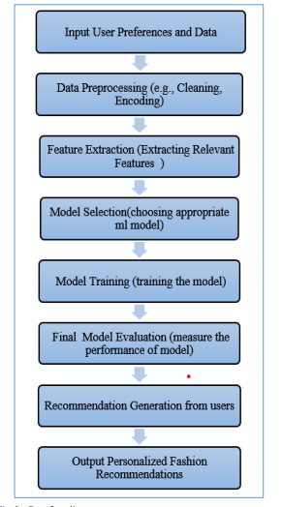

Materials and Tools

* **Datasets**: Annotated body shape images, fashion catalogs, and user feedback data.
* **Outfit dataset**:

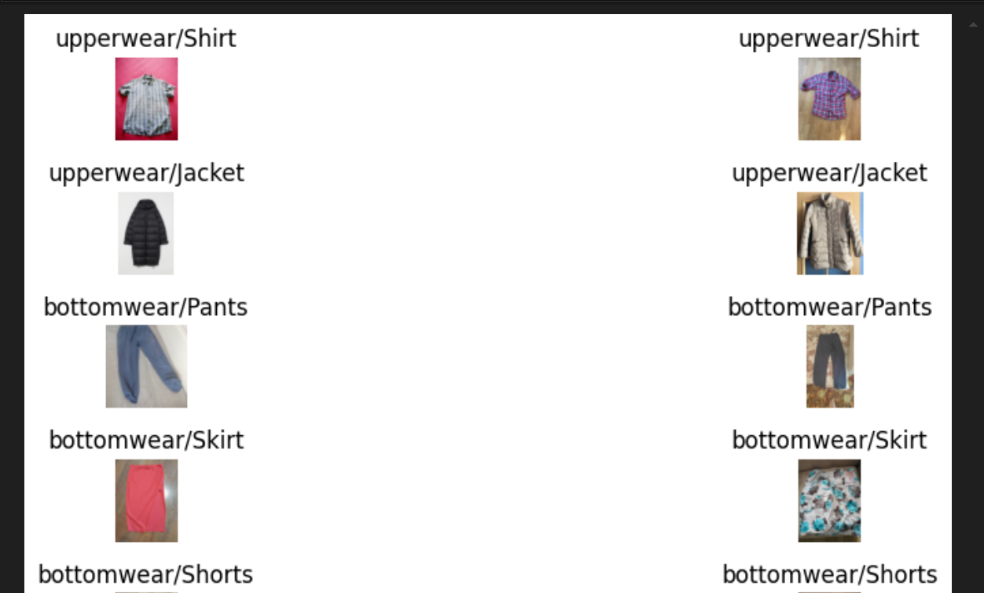

**Body Shape Dataset:**

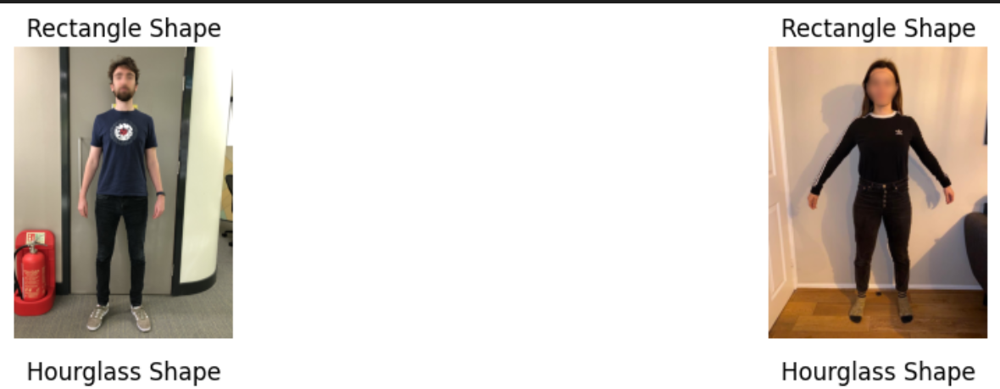

* **Libraries**: TensorFlow, CV2, Matplotlib for visualization,PIL for image preprocessing ,pandas,numpy,sklearn
* **Hardware**: GPU-enabled system for model training.

**Process**

1. **Data Collection**: Collected labeled datasets of body shapes, fashion styles, and user preferences.
2. **Data Preprocessing**: Images were resized, normalized, and augmented to improve model robustness.
3. **Model Training**: Used a CNN model fine-tuned on body shape classification and integrated additional layers for preference handling and also use pre trained model for body shape detetction
4. **Recommendation Algorithm**: Combined body shape predictions with user-defined preferences for size, occasion, and color to generate customized recommendations.
5. **Deployment**: Integrated the model with a web-based interface for real-time recommendations, enabling users to input preferences easily.

**Visualizations**

**Body shape model accuracy and loss graph:**

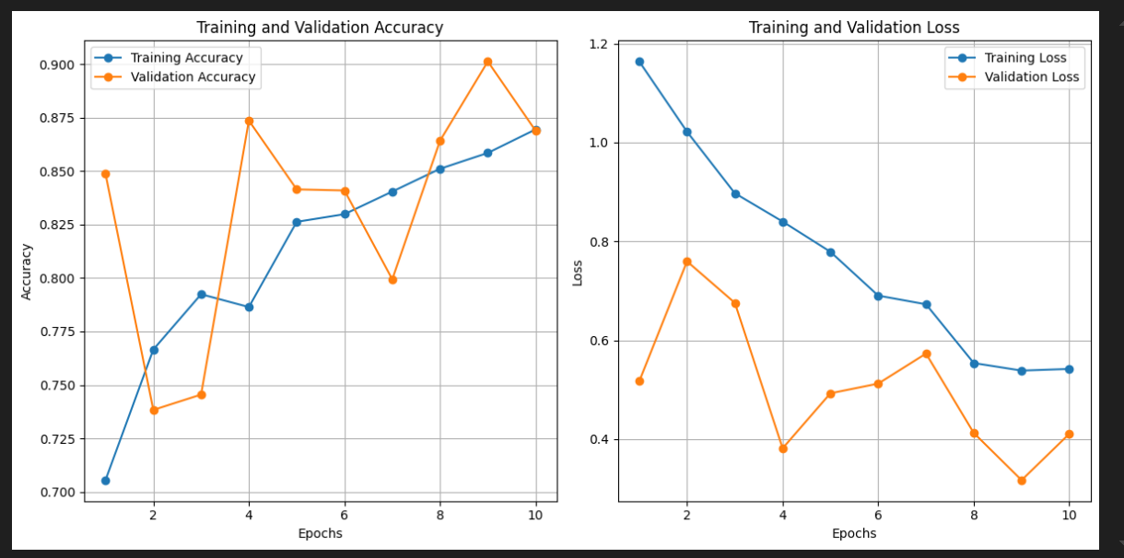

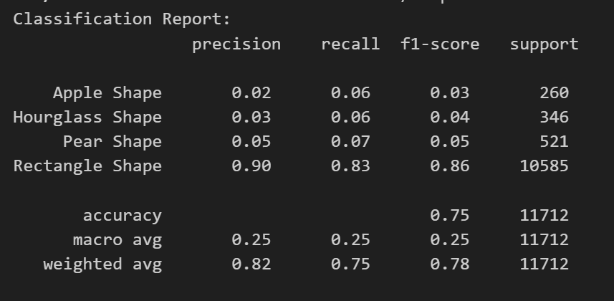

**Confusion matrix:**

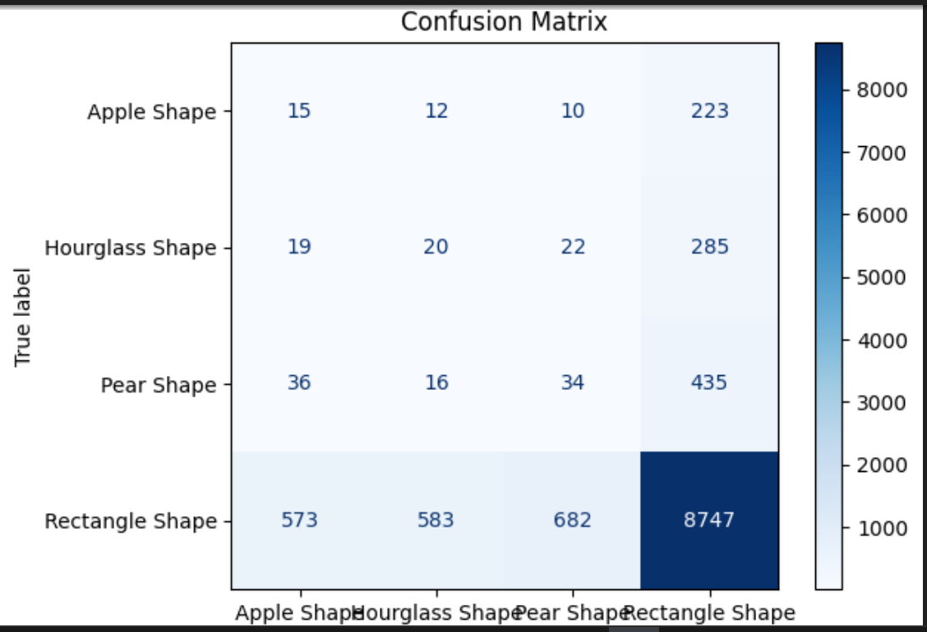

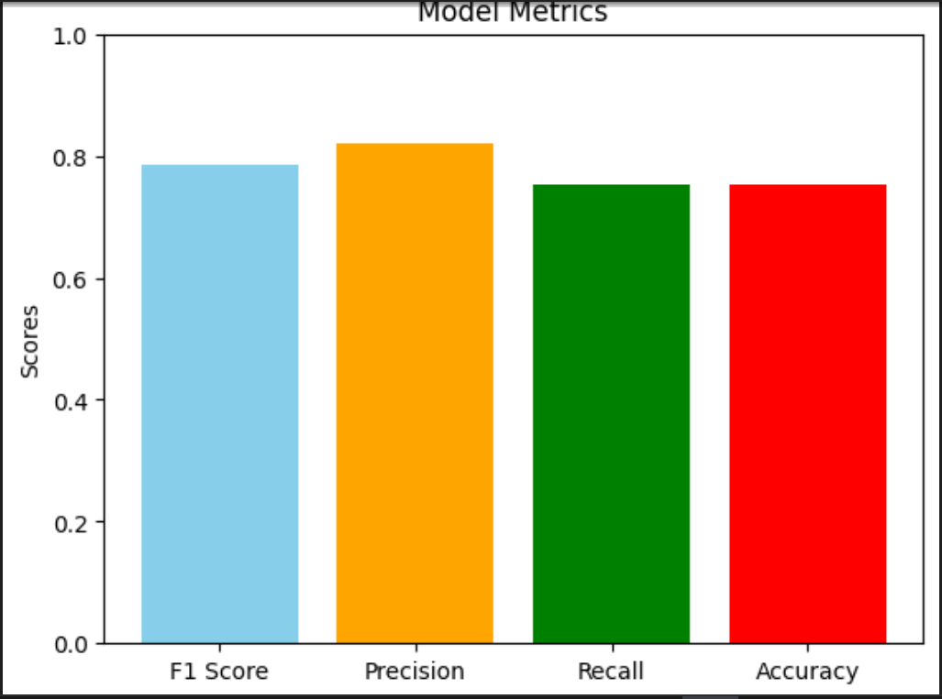

**Roc Curve**

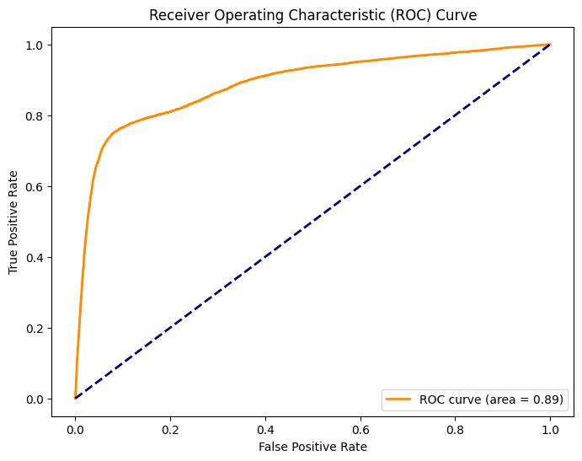

**Outfit recommendation model:**

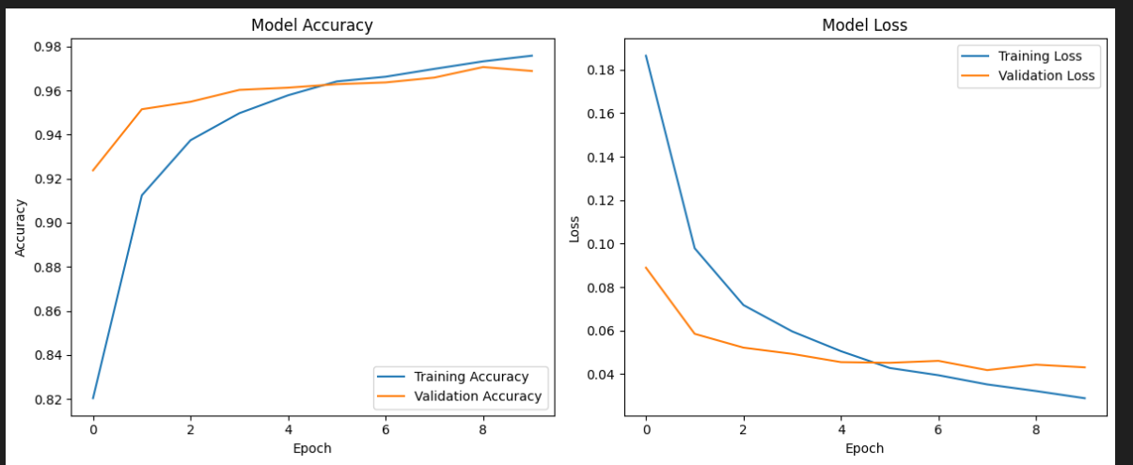

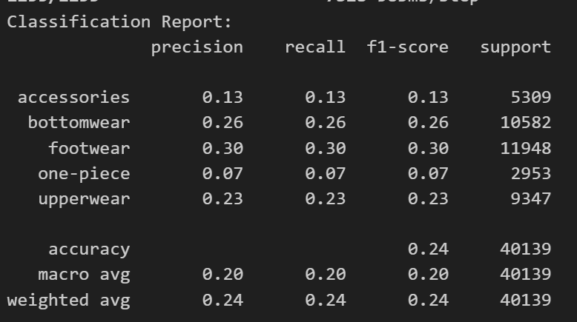

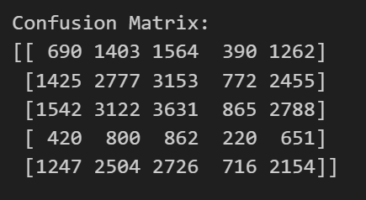

**Framework Diagram**

The system architecture from input to output, including user inputs, model processing, and output generation.

**User Interface**



**User upload picture**

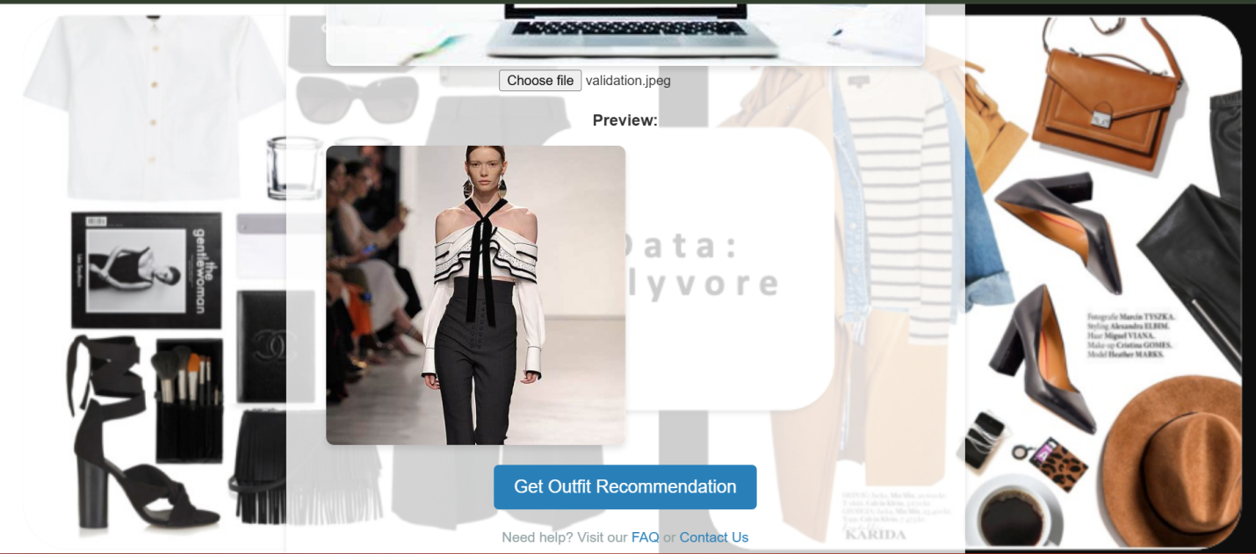

**Recommendations**

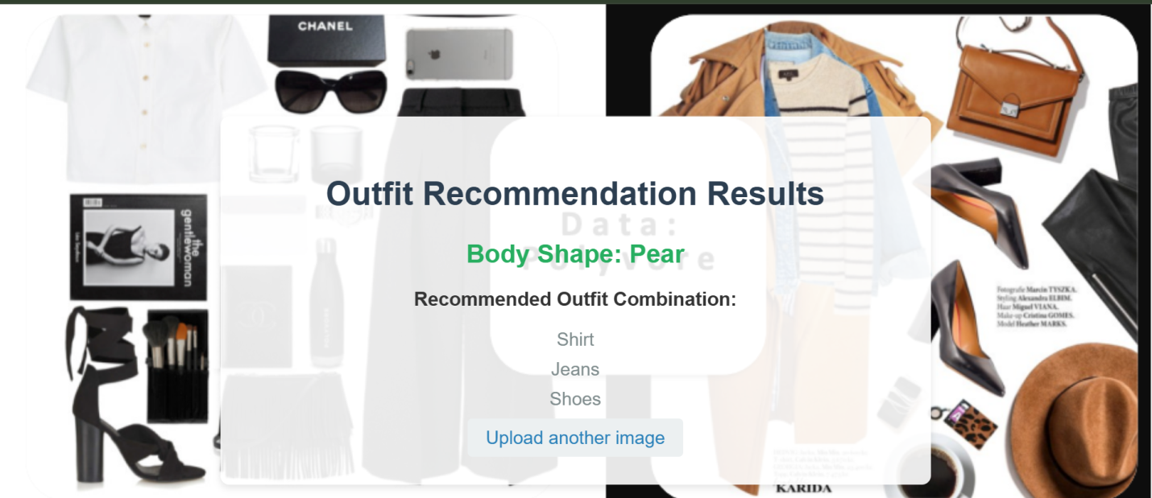

**Results**

**Key Findings**

* **Model Accuracy**: Achieved 75% accuracy in body shape classification using CNN-based methods.
* **Recommendation Success**: User testing showed improved satisfaction with style recommendations tailored to body shapes and preferences.

**Gaps Identified**

1. Limited exploration of contextual factors like user preferences, age, or skin tone.
2. Real-time deployment and scalability for diverse datasets remain a challenge.
3. Body shape classification accuracy, while improved, could still be optimized for broader applications.

**Conclusion**

The AI-driven outfit recommendation system effectively bridges the gap in body shape-focused solutions. By combining deep learning and user-centric design, the system delivers tailored recommendations, enhancing user confidence and satisfaction. The system’s scalability and integration of multi-factor personalization set it apart from existing solutions. Future work includes expanding the dataset to include more diverse body shapes and integrating dynamic style trend analysis to keep the recommendations updated with current fashion trends.

**References**

1. Hidayati, S. C., Hsu, C.-H., Chang, S.-Y., Hua, K.-L., & Cheng, W.-H. (2018). What Dress Fits Me Best?: Fashion Recommendation on the Clothing Style for Personal Body Shape. *Proceedings of the 26th ACM International Conference on Multimedia*, 438–446.
2. Hsiao, W.-L., & Grauman, K. (2020). ViBE: Dressing for Diverse Body Shapes. *Proceedings of the IEEE/CVF Conference on Computer Vision and Pattern Recognition (CVPR)*, 10940–10950.
3. Sarkar, R., Dave, A., Medioni, G., & Biggs, B. (2023). Shape of You: Precise 3D Shape Estimations for Diverse Body Types. *arXiv preprint arXiv:2304.07389*.
4. Trotter, C., Peleja, F., Dotti, D., & de Santos, A. (2023). Human Body Shape Classification Based on a Single Image. *arXiv preprint arXiv:2305.18480*.
5. Zong, Y. (2022). Dress Style Recommendation Based on Female Body Shapes. *Master's Thesis, Cornell University*.
6. Depuru, S. S. S. R., & others. (2022). Advanced Fashion Recommendation System for Different Body Types using Deep Learning Models. *ResearchGate*.
7. Hsiao, W.-L., & Grauman, K. (2019). Dressing for Diverse Body Shapes. *arXiv preprint arXiv:1912.06697*.
8. Ma, Y., Yang, X., Liao, L., Cao, Y., & Chua, T.-S. (2019). Who, Where, and What to Wear?: Extracting Fashion Knowledge from Social Media. *Proceedings of the 27th ACM International Conference on Multimedia*, 257–265.
9. Kang, W.-C., & McAuley, J. (2017). Learning Fashion Compatibility with Bidirectional LSTMs. *Proceedings of the 2017 ACM on Conference on Information and Knowledge Management*, 1079–1088.
10. Veit, A., Kovacs, B., Bell, S., McAuley, J., Bala, K., & Belongie, S. (2015). Learning Visual Clothing Style with Heterogeneous Dyadic Co-occurrences. *Proceedings of the IEEE International Conference on Computer Vision (ICCV)*, 4642–4650.
11. Han, X., Wu, Z., Wu, Z., Yu, R., & Davis, L. S. (2017). Viton: An Image-Based Virtual Try-On Network. *arXiv preprint arXiv:1711.08447*.
12. Zhou, F., & Zha, H. (2012). Learning Binary Codes for Collaborative Filtering. *Proceedings of the 18th ACM SIGKDD International Conference on Knowledge Discovery and Data Mining*, 498–506.
13. He, R., & McAuley, J. (2016). VBPR: Visual Bayesian Personalized Ranking from Implicit Feedback. *Proceedings of the AAAI Conference on Artificial Intelligence*, 30(1).
14. Song, Y., Jiang, H., Song, Y., Gao, L., & Shen, H. T. (2019). Neural Compatibility Modeling with Attentive Knowledge Distillation. *Proceedings of the 27th ACM International Conference on Multimedia*, 1450–1458.
15. Lin, Y.-L., & Kiapour, M. H. (2018). Fashion Outfit Complementary Item Retrieval. *arXiv preprint arXiv:1806.11371*.
16. Kang, W.-C., Fang, C., Wang, Z., & McAuley, J. (2019). Visually-Aware Fashion Recommendation and Design with Generative Image Models. *2019 IEEE Winter Conference on Applications of Computer Vision (WACV)*, 238–247.
17. Liu, Z., Luo, P., Qiu, S., Wang, X., & Tang, X. (2016). DeepFashion: Powering Robust Clothes Recognition and Retrieval. *Proceedings of the IEEE Conference on Computer Vision and Pattern Recognition (CVPR)*, 1096–1104.
18. Sattar, A., Pons-Moll, G., & Theobalt, C. (2019). Fashion is Taking Shape: Understanding Clothing Preference Based on Body Shape from Online Sources. *arXiv preprint arXiv:1904.01344*.
19. Hidayati, S. C., Hua, K.-L., & Cheng, W.-H. (2018). Learning Clothing Style Compatibility for Personal Body Shape. IEEE